Telling time: Quarter past, Half past, and Quarter to
30 minutes = Half past

15 minutes= Quarter past

45 minutes = Quarter to

Quarter Past | -----:15 | 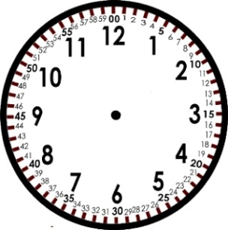
Half Past | ------:30
Quarter to | ------:45

Example:
7:15 |  | Quarter past 7
9:30 |  | Half past 9
2:45 |  | Quarter to 3

Practice:
12:45
10:30
2:30
7:15

1:30
6:45
11:30
4:45
6:45

10:30

