Telling Time: Using term 'To and Past'
We can say times three ways-
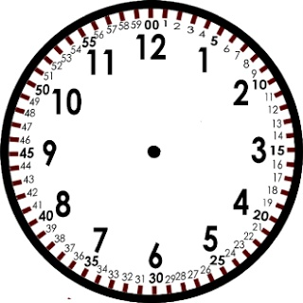

Hour : Minutes 8: 25
------- minutes Past ------(Hour) 25 minutes past 8
------- minutes To ------- (next Hour) 35 minutes To 9
I'll reach 5 after 25 minutes
I passed 35 minutes from 4

Telling time: Digital
Clock | Hour: Minute (2 digits)
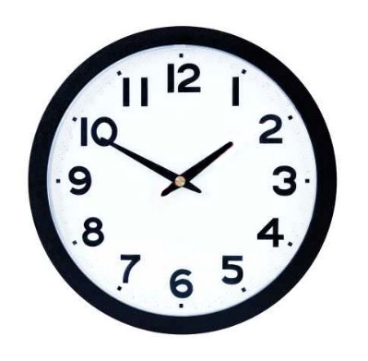 | 1:50
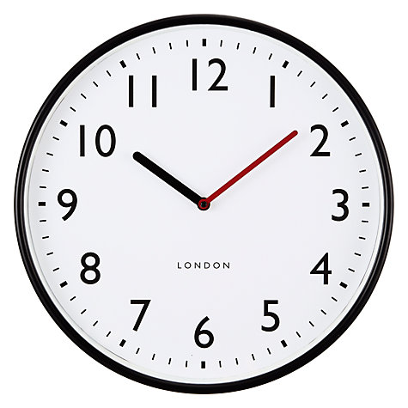 | 10:08

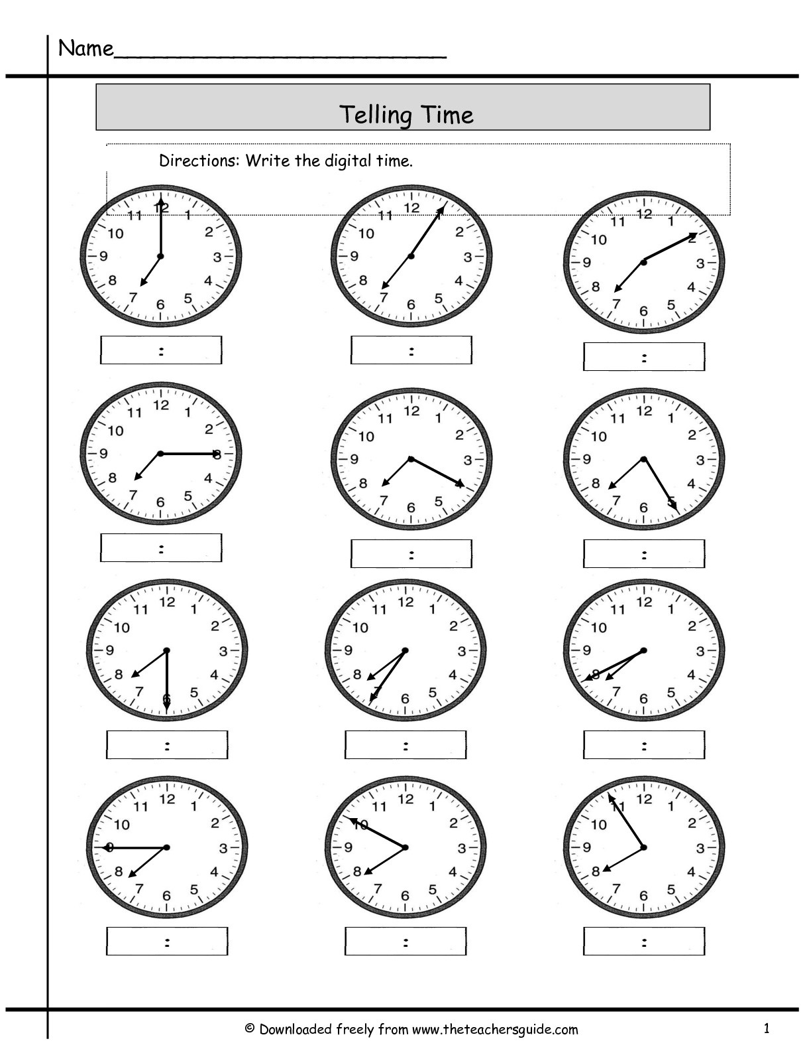

Telling Time: Analog
Using the term: Past
Digital-2:25

Analog-25 minutes past 2

Practice:
Example:

Using the term: Past
How to count 'to'?
Start from 12
And count counter clockwise.
12:40 | 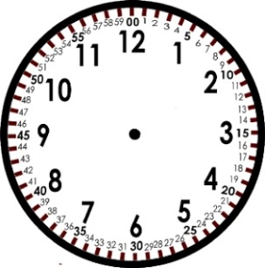 | 20 minutes to 1

Practice
12:45 |  | ---- minutes to ----

1:35 |  | ------ minutes to ----
2:40 |  | ----- minutes to ---
7:55 |  | ----- minutes to -----
9:35 |  | ----- minutes to -----
5:50 |  | ----- minutes to -----
6:35

Past or To

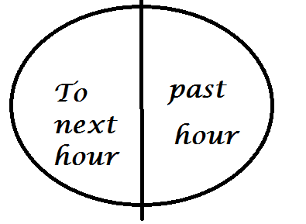

Past or To Practice:
12:20 |  | -------past------
6:35 |  | ---------to--------
9:55
3:40
7:10
5:50
9:05
6:25
1:10

1:35
2:10
7:15
9:35
5:55
7:05

10:30

7:45
9:30
2:55
7:15

1:30

